Scenario: check windowhandles
Step: Launch "WindowHandlePage" WebPage - PASS
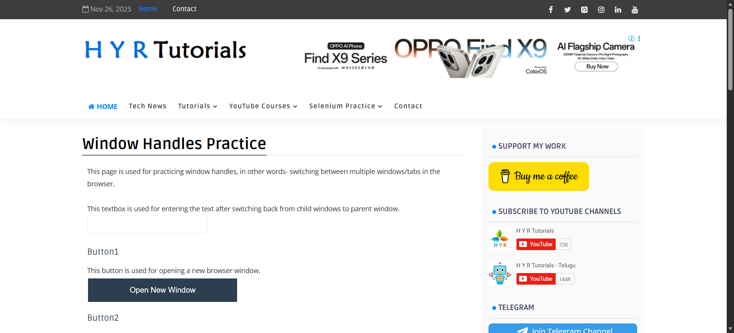
Step: User click the "Tab_Button" element at "WHPage" page - PASS
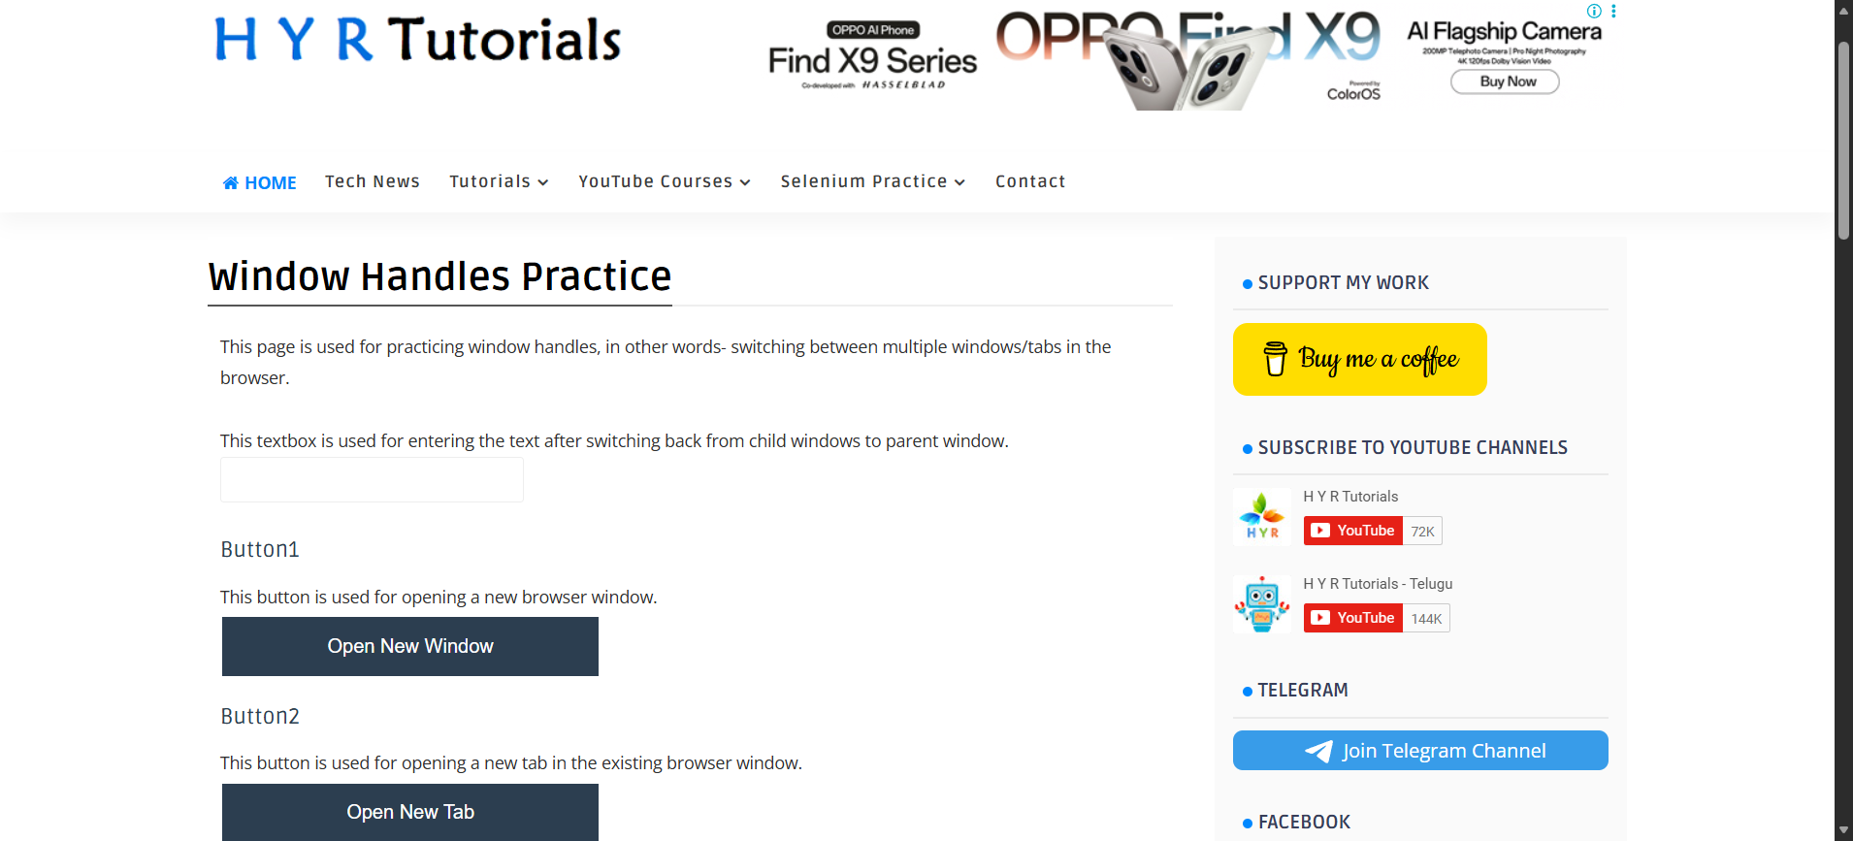
Step: And the user waits for "2" seconds - PASS
Step: Then the user switch to "firstWindow" - PASS
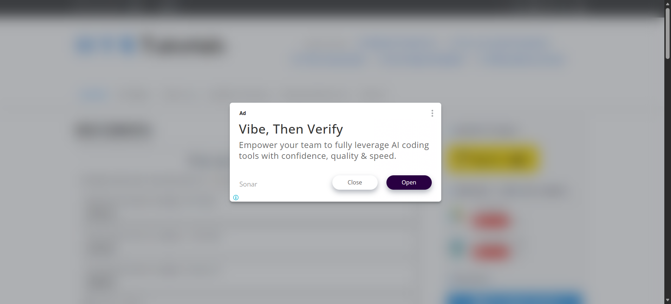
Step: Then the user switch to "firstWindow" - PASS
Step: And the user waits for "5" seconds - PASS
Step: Then the user switch to "parentwindow" - PASS
Step: User click the "Tab_Button" element at "WHPage" page - PASS
Step: And the user waits for "5" seconds - PASS
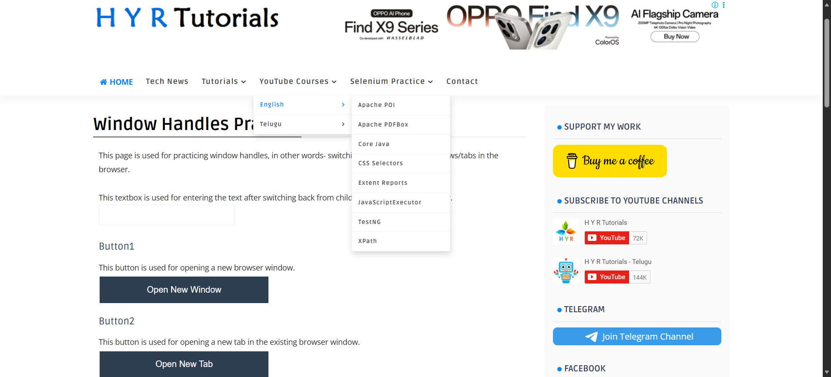
Execution Summary:
Total Steps: 9
Passed: 9
Failed: 0

